A Project Report On

**Travel Management System**

Submitted in partial fulfillment of the requirement for the award of the degree

Bachelor of Computer Application

BCA(Hons.)

Academic Year 2024 – 25

Mihir Bhayani – 92200577027

Karan Sundavadra – 92200577028

MananKumar Bhalodiya – 92200577038

Internal Guide

(Prof. **Vidhya Rachchh**)



Rajkot-Morbi Road, At & PO: Gauridad, Rajkot 360 003. Gujarat. India.



Faculty Of Computer Applications (FOCA)



**This is to certify that the project work entitled**

**Travel Management System**

**submitted in partial fulfillment of the requirement for**

**the award of the degree of**

**Bachelor of Computer Application**

B.C.A. (Hons.) C.C.

**of the**

**Marwadi University**

**is a result of the bonafide work carried out by**

Mihir Bhayani - 92200577027

Karan Sundavadra – 92200577028

Manan Kumar Bhalodiya – 92200577038

**during the academic year 2024-25**

Prof. **Vidhya Rachchh Dr. Sunil Bajeja Dr. R Sridaran**

|  |  |  |  |  |
| --- | --- | --- | --- | --- |
| **Faculty Guide** |  | **HOD** |  | **Dean** |

**DECLARATION**

I / We hereby declare that this project work entitled **TRAVEL MANAGEMENT SYSTEM** is a record done by me.

I also declare that the matter embodied in this project is genuine work done by me and has not been submitted whether to this University or to any other University / Institute for the fulfilment of the requirement of any course of study.

Place: Marwadi University , Rajkot

Date: 02/12/2024

Mihir Bhayani – 92200577027 Signature:______________

Karan Sundavadra – 92200577208 Signature:______________

Manan Kumar Bhalodiya – 92200577038 Signature:______________

CONTENTS

|  |  |  |
| --- | --- | --- |
| Chapters | Particulars | Page No. |
| 1 | Synopsis   * Overview * Features * Technical Details * Functionality Breakdown | 5 |
| 2 | Project Description   * Introduction * Objectives * User Workflow | 8 |
| 3 | Description of Each Module in Detail | 10 |
| 4 | Flowchart | 14 |
| 5 | Data Flow Diagram | 15 |
| 6 | Activity Diagram | 16 |
| 7 | GUI designs | 17 |
| 8 | Program Output | 18 |
| 9 | Conclusion | 19 |
| 10 | Learning During Project Work | 20 |
| 11 | Bibliography | 21 |

1. **Synopsis :-**

* **Overview :**

The Travel Management System is comprehensive application developed using Python’s Tkinter Library for the graphical user interface (GUI) and the ReportLab Library for generating PDF receipts.

It aims to streamline the process of booking travel packages, managing customer details and calculating costs associated with various travel options.

* **Features :**
  + **User – Friendly Interface:-**

The application provides an intuitive GUI that allows users to input their travel details easily.

* + **Customer Information:-**

Users can enter the personal details such as name, address, mobile number and email id. This information is crucial for generating travel receipts.

* + **Travel Package Selection:-**

The system offers three different travel packages that users can choose from. Each package contains a list of destinations.

* + **Dynamic Place Selection:-**

Depending on the selected package, users can choose from a list of destinations. The application dynamically updates the available places based on the selected package.

* + **Cost Calculation:-**

The system calculates the total cost of the travel package based on the selected place, number of persons and additional options such as: Ral Tax, Travelling Insurance, Extra Luggage and Accommodation Types (Standard, Economy, First Class).

* + **Receipt Generation and Print:-**

After calculating the total cost, users can generate a detailed receipt that includes all information about the booking. The receipt can be printed or saved as a PDF file.

* + **Reset And Exit Option:-**

Users can reset all fields to start a new booking or exit the application safely.

* **Technical Details :**
* **Programming Language :** Python
* **Libraries Used :**
  + Tkinter : For creating the GUI.
  + PIL (Pillow) : For image handling, specifically for displaying the logo.
  + ReportLab : For generating PDF receipts
* **Data Handing :** The system uses ‘**stringVar**’ & ‘**IntVar**’ from Tkinter to manage user inputs and selections efficiently.
* **Functionality Breakdown :**
  + **Input Handing :-** The application captures user inputs for personal information and travel preferences through various input fields and combo boxes.
  + **Cost Calculation Logic :**- The system incorporates a structured method to calculate costs based on user selections, ensuring accurate pricing and tax computations.
  + **Receipt Creation :**- The receipt function formats the booking details into a readable format and allows users to print or save the information.
  + **Dynamic Updates :**- The application dynamically updates the available options for places and prices based on user selections, enhancing the user experience.

1. **Project Description :-**

* **Introduction :-**

The Travel Management System is a desktop application designed to facilitate the booking and management of travel packages. Built using Python’s Tkinter library for the graphical user interface (GUI) and the ReportLab library for PDF generation, this application aims to streamline the travel booking process for users, making it easier to select packages, calculate costs and generate receipts.

* **Objectives :-**
  + To provide a user – friendly interface for customers to input their travel details.
  + To allow users to select from various travel packages and destinations.
  + To calculate the total cost of travel based on user selections and additional options.
  + To generate detailed receipts for bookings, which can be printed or saved as PDF files.
  + To ensure a smooth and efficient user experience through dynamic updates and clear information presentation.
* **User Workflow :-**
  + Input personal information.
  + Select travel package.
  + Choose the destination based on the selected package.
  + Specify additional options like ralve tax, travelling insurance, extra luggage and accommodation types.
  + Calculate total cost
  + After the confirming the details, users can generate a receipt, which can be printed or saved as a PDF.
  + Reset to the for a new booking and exit the application.

1. **Description Of Each Module In Detail :-**
2. **Main Application Module :-**
   * Initializes the main application window and sets up the overall layout.
   * **Key Components :** 
     + Window configuration to sets the title, size and bg color of the main window.
     + Icon setup the application using a specified image file.
     + Data initialization to computers the current date for use in receipts.
3. **User Input Module :-**
   * Manages user input for personal and travel details.
   * **Key Components :**
     + Utilizes Tkinter’s variable classes to store user inputs for names, addresses, contact information and travel preferences.
     + Provides entry fields for name, address, postcode, mobile number and email id.
4. **Travel Package Selection Module :-**
   * Allows users to select a travel package and corresponding destination.
   * **Key Components :**
     + Dropdown menus for selecting travel packages or destinations to based on to selecting the package.
     + Updates the available destinations based on the selected package using the `**update_places**` method.
5. **Cost Calculation Module :-**
   * Calculates the total cost of the travel package based on user selections.
   * **Key Components :**
     + Cost variables to stores costs for various options such as Ral Tax, Travelling Insurance, Extra Luggage and Accommodation types.
     + The `**Total_Paid**` function computes the total cost by summing the base price of the selected destination and any additional options selected by the user.
     + Calculates the applicable tax and updates the subtotal and total cost.
6. **Receipt Generation Module :-**
   * Generates a detailed receipt for the user’s travel booking.
   * **Key Components :**
     + Display the receipt information in a text area.
     + The `**Receipt**` function formats and inserts user details, travel package information and cost breakdown into the receipt.
     + The `**Print**` function allows users to save the receipt as a PDF file using the ReportLab library.
7. **Reset and Exit Module :-**
   * Provides functionality to reset the form or exit the application.
   * **Key Components :**
     + The `**Reset**` function clears all input fields, resets variables, and prepares the application for a new booking.
     + The `**Exit`** function prompts the user for confirmation before closing the application.
8. **Checkbox and Option Selection Module :-**
   * Manages additional options that can be selected by the user.
   * **Key Components :**
     + Provides checkboxes for options like Ral Tax, Travelling Insurance, Extra luggage and Accommodation types.
     + Each checkbox updates the corresponding cost variable and enables or disables related input fields based on user selection.
9. **User Interface Layout Module :-**
   * Organizes the layout of the application using frames and labels.
   * **Key Components :**
     + Divides the application into logical sections.
     + Provides clear labels for each input field and organizes them in a user – friendly manner.
10. **Image Handling module :-**
    * Manages the display of images within the application.
    * **Key Components :**
      + Uses the PIL (Pillow) library to load and resize the logo image for display in the application.
11. **Flow Chart :-**

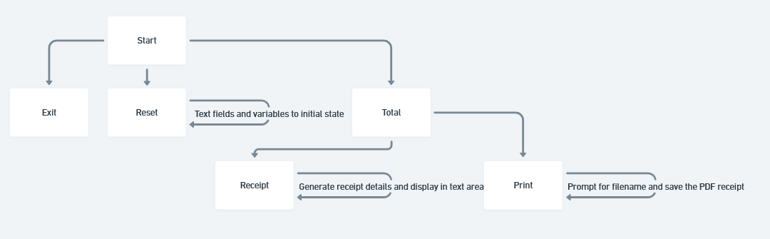

1. **Data Flow Diagram :-**

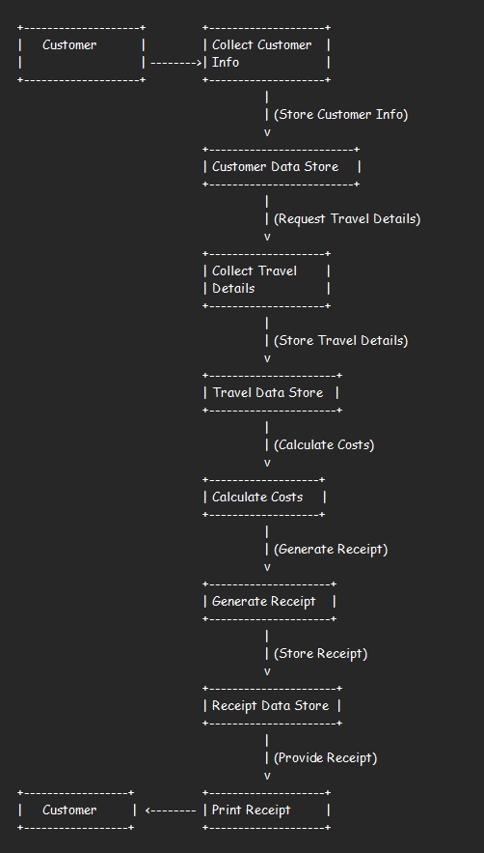

1. **Activity Diagram :-**

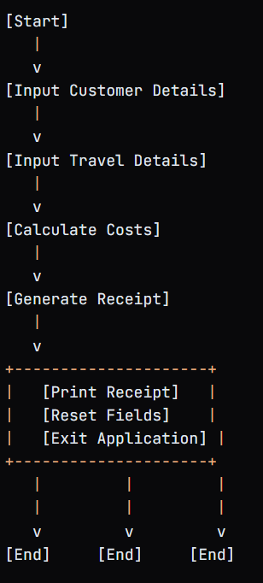

1. 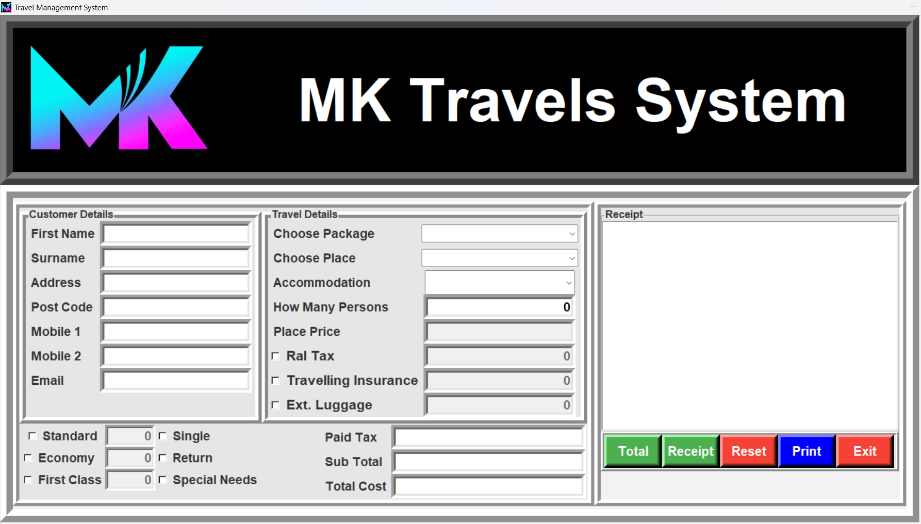**GUI Designs :-**
2. 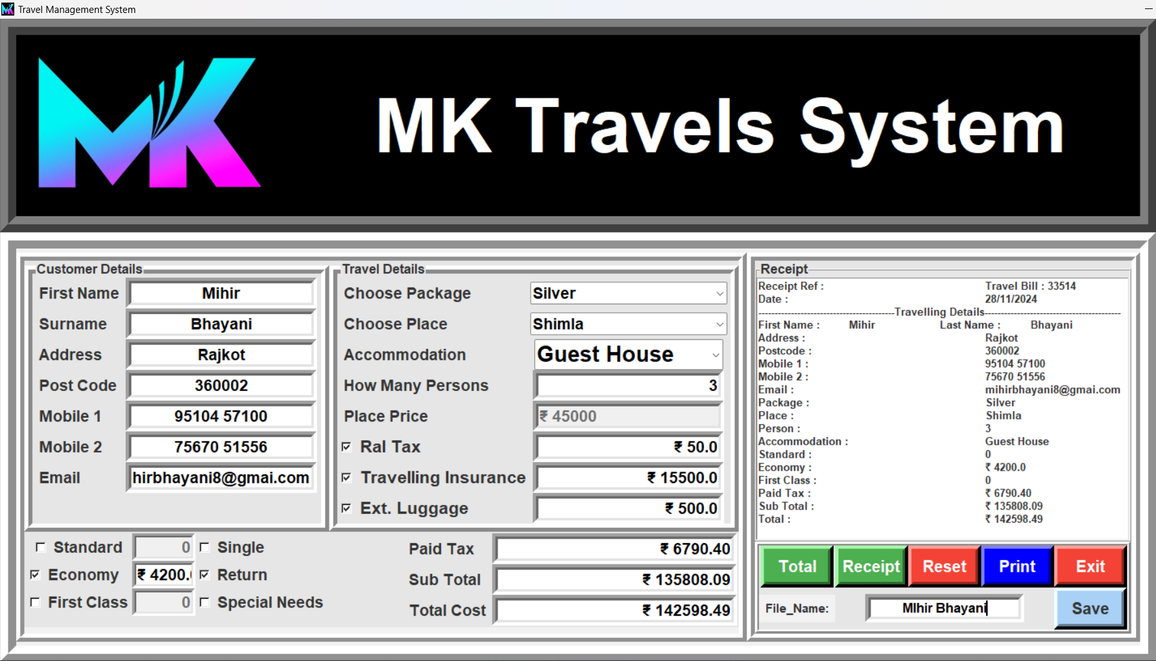**Program Output :-**
3. **Conclusion:-**

The Travel Management System developed using Tkinter offers a user-friendly interface for managing travel bookings and customer details.

This Travel Management System is a robust solution for managing travel bookings, providing essential functionalities that cater to both the user and the travel agency's needs. It demonstrates the capabilities of Tkinter in creating interactive applications while showcasing best practices in software design, such as modular function definitions and user input validation.

1. **Learning During Project Work :-**

When working on a travel management system using python and a GUI framework like Tkinter, you’ll gain valuable skills in several areas.

* + - 1. user interface design
      2. application logic
      3. problem-solving skills
      4. project management

you will have a comprehensive understanding of how to build a functional travel management system ,equipping you with skills that are highly valuable in the software development industry.

1. **Bibliography :-**

* **Online References :-** <https://youtu.be/x3Syb3N0E6o?si=ZdDrDD6riNcpje-C>
  + **This you tube link**

<https://www.w3schools.com/python/>

* + W3schools